

Instruction Manual

AccuSafe Sensor Module

Table of Contents

Section 1 - Introduction 2

1.1. Important Safeguards 2

*1.2.1. Sensor MODULE Configuration* 3

1.2. Accusafe Sensor Specifications 3

Section 2 – Installation 4

2.1. Enclosure Wall Mounting 4

2.2. Wiring and Pneumatic Connections 5

*2.1.1.* *Power and MODBUS connections* 5

2.3. Getting started 7

*2.3.1. CONNECTING SENSOR CARTRIDGE TO CONTROLLER MODULE* 7

Section 3 - Operation 10

3.1. Pneumatic Operation Modes 10

*3.1.1. Gas Sensor Categories* 10

*3.1.2. FLOW RATE* 11

3.2. MODBUS Operation 12

*3.2.1. RTU RS485 Configuration* 13

*3.2.2. MODBUS Specifications* 14

*3.2.3. Input Registers* 14

*3.2.4. Holding Registers* 15

Section 4 - Calibration 16

4.1. CALIBRATION OPTIONS 16

4.2. Zero Calibration 17

*4.2.1. Zero Calibration Procedure* 18

4.3. Calibration PROCEDURES 19

*4.2.1. Gas Calibration Procedure* 20

*4.2.2. Digital Calibration Procedure* 24

Section 5 – ACCUSAFE SENSOR MODULE MAINTENANCE 26

5.1. Cartridge Replacement 26

5.2. RECYCLING SENSOR CARTRIDGES 26

Section 6 – SENSOR MODULE TESTER APP 27

Section 7 - Warranty 30

Section 8 - Customer Service 31

8.1 Return Authorization 31

## Section 1 - Introduction

### 1.1. Important Safeguards

To reduce the risk of fire, electrical shock, injury to persons or permanent damage to this device, these safety precautions should always be followed:

* Use the included 12VDC power supply or specified power connector to operate this device. Inappropriate voltage supply or power connector could cause irreparable damage to this device.
* Make sure the power plug and Modbus cable are plugged in and secured before powering up the device. The power connector will not make connection to GND if not fully plugged into the socket.
* If sampling via tubing, make sure that the tubes are securely attached to the device before operating.
* Do not operate the device with an obstructed flow path. Obstruction during air sampling will damage the internal micropump.
* Do not expose this device to any liquids.
* Sensors must not be exposed to temperature, humidity and pressure that are outside the operating range.

#### *1.2.1. Sensor MODULE Configuration*

This section details the specific parameters related to gas type, range and recommended calibration settings for your AccuSafe instrument. If your system contains multiple sensor modules, each module’s setup is detailed in the list below. Highlighted sections indicate user settings to be input in maintenance modes. All other sections indicate factory settings.

### 1.2. Accusafe Sensor Specifications

|  |  |
| --- | --- |
| Measurements | Target Gas, RH, Temperature, Barometric Pressure |
| Air Sampling Rate | 50-350 ccm |
| Measuring Rate | 1 sample per second |
| Communication | Modbus via RTU/RS485 & TCP/IP |
| Sampling Port | Inlet/outlet with Luer lock fittings |
| Operating Environment | 0°C - 50°C, 15-90% relative humidity non-condensing |
| Power Input | 12VDC regulated |
| Avg. Power Consumption | 2.5W |
| Dimensions | 8 in x 4.7 in x 2.2 in (includes mounting flanges) |
| Weight | 0.98kg |
| Enclosure | Powder-coated aluminum |

|  |  |
| --- | --- |
| Type | 3 electrode electrochemical |
| Nominal Range | See section 1.2.1 below |
| Accuracy | ± 5% of reading ± least significant digit |
| Response Time (T90) | < 2 minutes (varies widely by gas type) |
| Temperature Range | -20 °C to 50 °C (varies by gas type) |
| Pressure Range | atmospheric ± 10 % |
| Relative Humidity Range | 15 % to 90 % R.H. non-condensing |
| Long Term Output Drift | < 2 - 5 % per month in continuous exposure (varies by gas type) |
| Lifetime | 2 – 3 years (varies by gas type) |

## Section 2 – Installation

### 2.1. Enclosure Wall Mounting

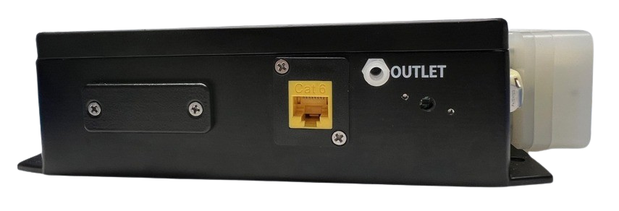

**ModBus Communication Port**

**Gas Outlet**

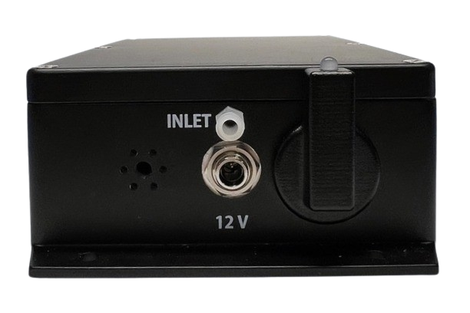

**\*\*Power**

**On LED**

**12V Power Receptacle**

**Gas Inlet**

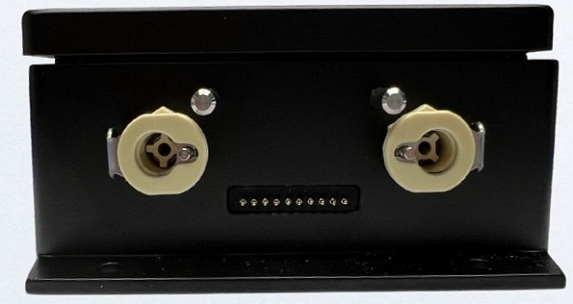

**\*Inlet Latches**

**Mounting Holes**

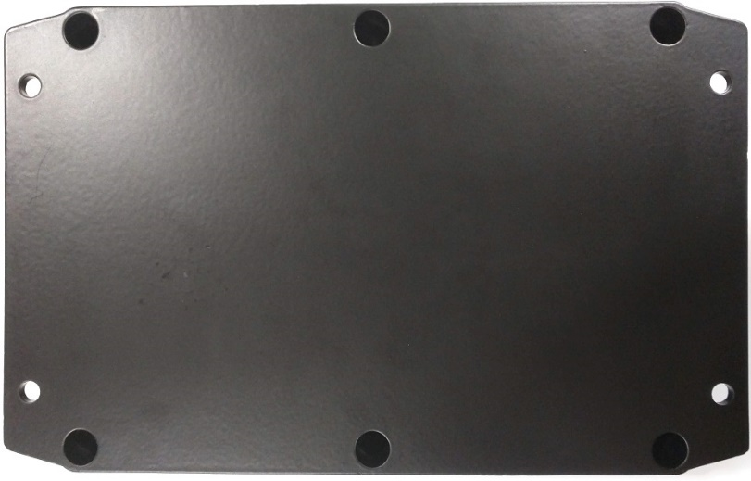

Figure 1- Sensor Module Breakdown

The sensor module is wall mountable using M5 or #10 screws. Install the module in the immediate area from which you want to draw the sample. Although consideration should be given to whether the target gas is heavier or lighter than air, generally the sensor module should be mounted with the inlet at nose level for the average person. **Allow for 18” total horizontal space to accommodate pneumatic and cabling connections to the sides of the enclosure.**

### 2.2. Wiring and Pneumatic Connections

#### *2.1.1.* *Power and MODBUS connections*

To connect the device to power, connect the 12V power adapter, included with your device, to the sensor module by inserting the plug into the 12V power receptacle and tightening the lock ring snugly *(See Figure 1).* There is no power switch on the sensor module.

**For TCP/IP communications applications,** connect a standard CAT5 communications cable to the MODBUS communications port. This cable will connect to the ETHERNET port on the **\*AccuSafe** controller module for non-web browser single sensor applications or to an Ethernet switch or hub for single or multi-sensor applications that utilize the web browser application.

**\*NOTE:** The **AccuSafe** controller manual can be found on our website or by [clicking here](https://gasdetection.com/support/accusafe/).

I-901 CONTROLLER

MODBUS RTU

MODBUS TCP/IP

TCP/IP SENSOR 2

ETHERNET

TCP/IP SENSOR 1

TCP/IP ACTUATOR

ETHERNET ROUTER/SWITCH

Figure 2: Example Hub connection configuration

**For** **RTU (RS485) communications applications**, connect a standard CAT5 communications cable to the MODBUS communications port. This cable will connect to the “RS485” port on the AccuSafe controller module for single sensor applications or to the next sensor in the daisy chain for multi-sensor applications**\*\***.

I-901 CONTROLLER

ETHERNET

SENSOR 1 IN RTU MODE

SENSOR 2 IN RTU MODE

RTU ACTUATOR

Figure 3 Example Controller and Sensor direct connection

**\*\*NOTE:** Multi-sensor applications using RS485 connections will require a splitter device be used at each node in the chain, using a multi-drop (daisy chain) topology.

**IMPORTANT:**

* Make sure power cable and modbus cable are **secured** before powering up device.
* Make sure there is no flow obstruction at inlet/outlet before powering up device.

### 2.3. Getting started

The sensor cartridge will come pre-installed with your AccuSafe sensor module.

### *2.3.1. CONNECTING SENSOR CARTRIDGE TO CONTROLLER MODULE*

Your **AccuSafe Controller** will come pre-installed with the sensor cartridge panels specific to your cartridge sensors. However, depending on what communication mode you are utilizing *(See Section 2.2.1)*, you may need to adjust your panels for connection between the controller and the sensor to work. Please refer to the following instructions for how to adjust or create a new panel for your sensor cartridge:

1. Connect your controller to the sensor module through Modbus TCP/IP or Modbus RTU. *(See Section 2.2.1)*.
2. Navigate to the **Calibration** menu indicated by a gage icon.



1. Select the **Cartridges** button located at the top right corner of the Calibration Screen screen.

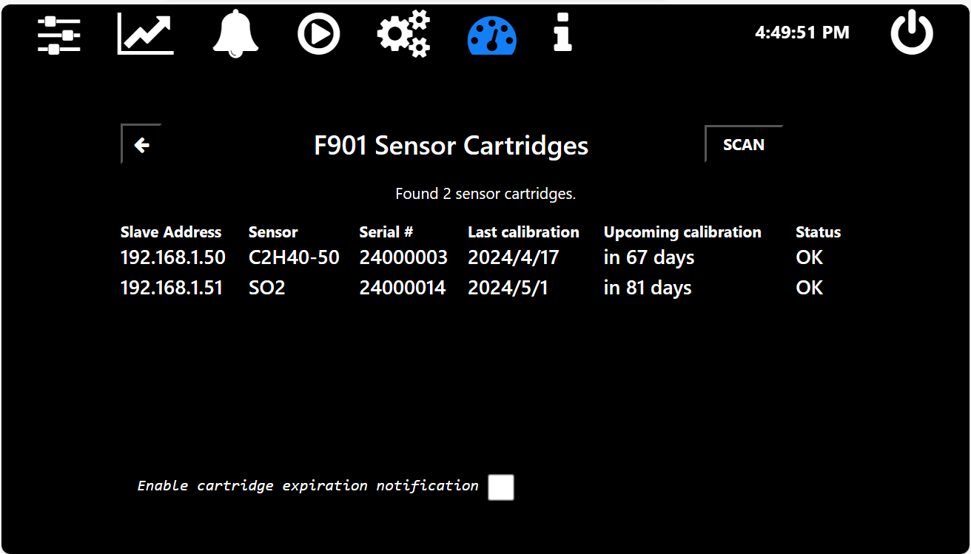

1. Press the **SCAN** button. Details about the installed cartridge should then be displayed.

If the controller does not recognize the cartridge, check:

* 1. That the sensor module and controller are properly connected and both connected to power.
  2. Panels exist referencing the TCP/IP or RTU addresses of the sensor module.

1. On the Controller, navigate to the **Panel Configuration menu** indicated by the gears icon in the menu bar. Type in the system default password **1111** and select the blue check button.

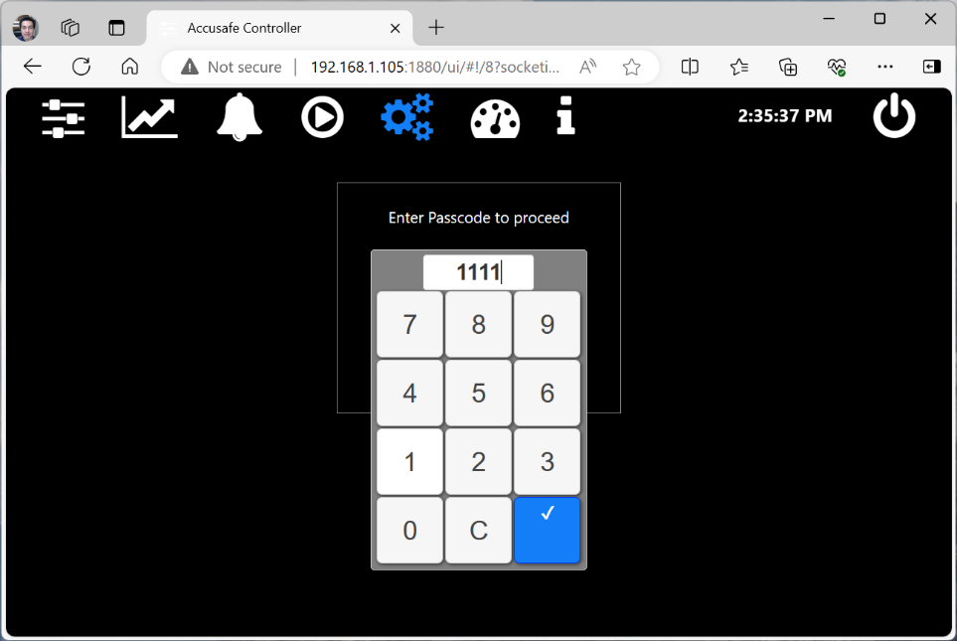

Figure 4- Panel Editor Password Screen

1. Verify if the panel(s) installed on your controller matches the sensor cartridge(s) installed to your sensor module(s). The panel will be named **Sys# [GAS TYPE].** *(See Figure 5).*

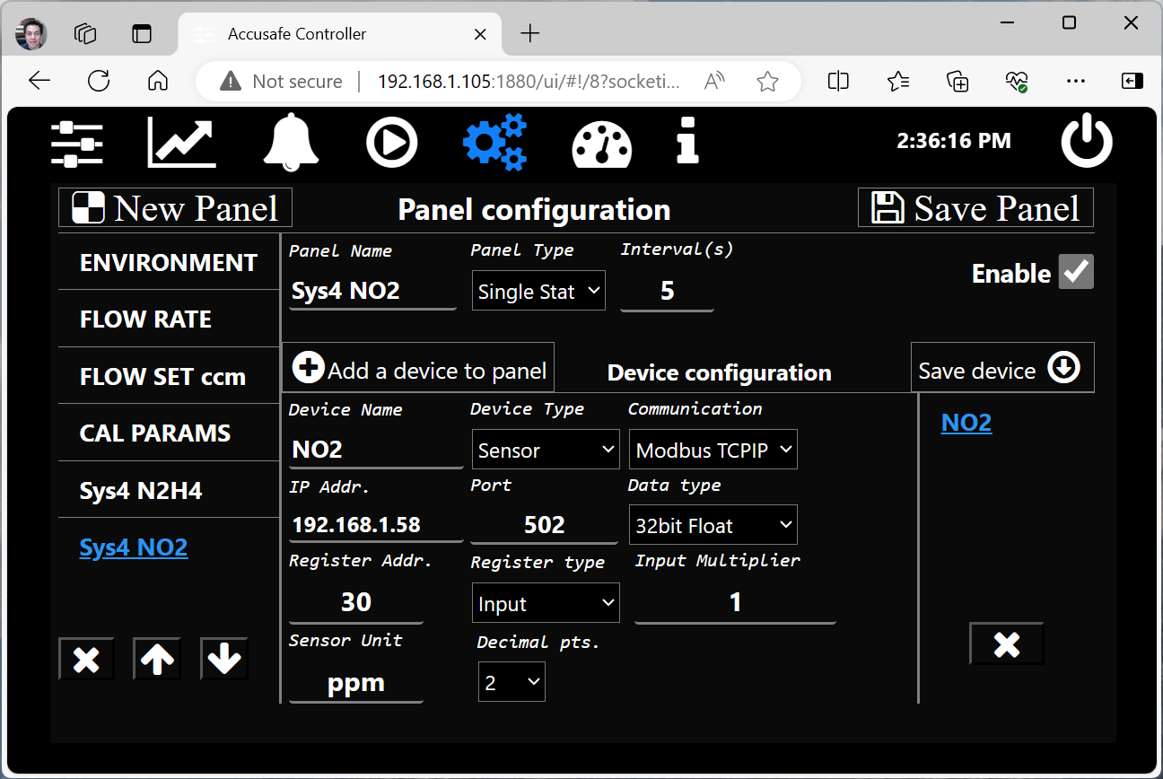

Figure 5- Panel Configuration Screen

**If there isn’t a panel already loaded onto your device, please refer to a-b**. for panel creation instructions. If the panel already exists, continue to Step 5.4.

* 1. Select **New Panel,** then enter the desired panel name in the **Panel Name** field.



Figure 6- New Panel Creation Buttons



**192.168.1.5**

Figure 7- Panel Configuartion Fields

* 1. Select **Add a device to panel,** enter the following information in this order:

**Device Name –** Enter the name of your gas sensor type.

* + 1. **Device Type –** Select Sensor.
    2. **Sensor Unit –** Enter desired unit (ppm is recommended).

1. All other fields can remain as defaulted.
2. Please refer to the [**AccuSafe Controller Manual**](https://gasdetection.com/support/accusafe/) for further guidance on panel settings.
   1. The IP address or slave address of the sensor module can be adjusted based on your desired configuration by editing the following fields:
      1. **Communication –** Select desired communication mode from the dropdown menu.
      2. **IP Addr. / Slave Address –** 
         1. **For TCPIP –** Default: 192.168.1.50.
         2. **For RTU –** Default: 50.
   2. **Register Address –** Set to **30**.



1. Select **Save Device,** check the **Enable** checkbox, then finally, select **Save Panel** to save the panel**.**

Figure 8- Saving Panel

## Section 3 - Operation

### 3.1. Pneumatic Operation Modes

The **AccuSafe Sensor Module** houses all the pneumatic components and Modbus microprocessors that interface with the Controller module ***(See the*** [***AccuSafe Controller Manual***](https://gasdetection.com/support/accusafe/) ***to for operation of the controller).***

**PUMP**

**SENSOR CARTRIDGE**

**GAS**

**INLET**

**OUTLETTUT**

Figure 9- Illustration of Continuous Sampling Configuration

**GAS**

**GAS**

The sensor module is configured to run continuously. The sample pump continuously draws the sample into the inlet and pushes it through the gas sensor. Gas concentration values are displayed continuously in real time. The gas sensor cartridge’s output signal is communicated via Modbus to the controller which then displays this signal in graphical and numeric forms.

#### *3.1.1. Gas Sensor Categories*

The durability of the **AccuSafe** gas sensor cartridge can vary depending on its exposure to specific target gases. Continuous exposure to these gases may shorten the cartridge's effective lifespan, influencing the choice of operation mode. Below, we categorize sensors and gases according to their impact on sensor longevity and the recommended operational approach. Please refer to Calibration section for more information on maintaining your sensor’s calibration cycle and lifespan *(See Section 4)*.

The following gas types rapidly deplete by continuous ***HIGH concentration*** exposure to the target gas. In applications where continuous, ***LOW concentration*** exposure, or occasional s pot measurements of target gas over the full measuring range is expected:

* **CH₂O:** Formaldehyde
* **Cl₂:** Chlorine
* **ClO₂**: Chlorine dioxide
* **CS₂:** Carbon disulfide
* **NO₂:** Nitrogen dioxide
* **O₃:** Ozone
* **SO₂:** Sulfur dioxide

The following gas types rapidly deplete by continuous exposure to the target gas at **ANY** level. **These sensor types should only be used in detection applications where presence of target gas is brief or abnormal:**

* **C₂H₄:** Ethylene
* **C₂S:** Dicarbon monosulfide
* **H₂S:** Hydrogen sulfide
* **H₂O₂:** Hydrogen peroxide
* **HCl:** Hydrogen chloride
* **HCN:** Hydrogen cyanide
* **NH₃:** Ammonia
* **PH₃:** Phosphine
* **SiH₄:** Silane

#### *3.1.2. FLOW RATE*

The instrument regulates the sample flow rate by adjusting the micropump speed and monitoring the air flow sensor. The set flow rate can be set in Modbus Holding register 0**.**

**NOTE:** It is NOT recommended that the flow rate be altered from its factory setting. Consult with the Interscan service dept. for any concerns about flow rate.

### 3.2. MODBUS Operation

The Sensor Module supports the standard Modbus protocol in both RTU and TCP/IP modes. The 3 available operation modes are detailed below. (see MODBUS MODE in table 3-4, pg. 15 for Modbus mode register addressing information). AUTO MODE is the recommended mode and is factory set prior to shipment:

* **AUTO Mode (factory preset mode) –**

In this mode, if the sensor detects a connection to an active Ethernet device, it will initialize Modbus TCP/IP protocol via the default static IP address 192.168.1.XX port 502 (The suffix of this address will be indicated on a label next to the Ethernet port. Address is configurable via Modbus commands where necessary. See SLAVE ADDR in Table 3-4, pg. 15). If not connected to an Ethernet connection, it will initialize in RTU mode.

* **Fixed TCP/IP mode –**

Upon powering up, the Sensor Module always initializes the Modbus TCP/IP protocol via the default static IP address 192.168.1.XX port 502 (The suffix of this address will be indicated on a label next to the Ethernet port. Address is configurable via Modbus commands where necessary. See SLAVE ADDR in Table 3-4, pg. 15). This is the default

* **Fixed RTU mode -**

Upon powering up, the Sensor Module always initializes the Modbus RTU protocol via the default static IP address 192.168.1.XX port 502 (The suffix of this address will be indicated on a label next to the Ethernet port. Address is configurable via Modbus commands where necessary. See SLAVE ADDR in Table 3-4, pg. 15). If the customer is interested in having their sensor boxes set to Fixed RTU mode by default, then they should contact the Interscan Sales department.

**NOTE:** The Sensor Module’s internal communications cabling is factory configured to operate in TCP/IP mode. If operating in RTU mode is desired, the internal communications cabling will need to be swapped. Contact the INTERSCAN SERVICE DEPT. for more information on making this change.

#### *3.2.1. RTU RS485 Configuration*

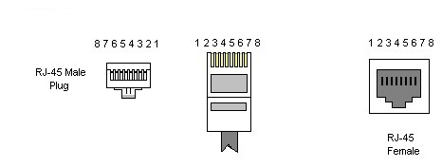

Bottom View

RS485 cabling configuration is shown in the diagrams and table 3-1 below.

|  |  |  |  |
| --- | --- | --- | --- |
| Pin | Name | Type | Description |
| 1 |  |  |  |
| 2 | GND | Reference potential | Local device ground |
| 3 |  |  |  |
| 4 | B (D-) | Bus In/Out | Driver output and receiver input |
| 5 | A (D+) | Bus In/Out | Driver output and receiver input |
| 6 |  |  |  |
| 7 |  |  |  |
| 8 |  |  |  |

*TABLE 3-1*

**IMPORTANT**: use pin 4,5 (B/A) and GND for Modbus RS485 communication.

**Absolute Maximum Rating**

Voltage range at A or B ………………………………………………. -8V to 12V

Electrostatic discharge at A and B ………………………………. ±8kV

RS485 Modbus Parameters

|  |  |
| --- | --- |
| Parameter | Value |
| Default address | 50 |
| Baud Rate | 19200 |
| Data bits | 8 |
| Parity | Even |
| Stop bits | 1 |

*TABLE 3-2*

#### *3.2.2. MODBUS Specifications*

* Operates as a slave, half-duplex mode
* Modbus functions supported:
  + 0x01 - Read Coils
  + 0x03 - Read Holding Registers
  + 0x04 - Read Input Registers
  + 0x05 - Write Single Coil
  + 0x06 - Write Single Register
  + 0x0F - Write Multiple Coils
  + 0x10 - Write Multiple Registers
* **Default Addresses:** 
  + **RTU:** 50
  + **TCP/IP:** 192.168.1.50

#### *3.2.3. Input Registers*

|  |  |  |  |
| --- | --- | --- | --- |
| **NAME** | **ADDRESS** | **DATA TYPE** | **REGISTER NUMBER** |
| DEV_TYPE_IREG | 100 | 16-bit unsigned | Device code. 9010 = 901A , 9011 = 901B, 9013 = 901D |
| FIRMWARE_VERSION_IREG | 101 | 16-bit unsigned | Device firmware version |
| HW_ERR_IREG | 102 | 16-bit unsigned | Hardware error code. 0= no err, 2 = Flow sensor err, 3 = RH/T sensor err. |
| FLOW_mV_IREG | 5 | 16-bit unsigned | Flow sensor output mV |
| FLOW_CCM_IREG | 6 | 16-bit unsigned | Flow sensor output ccm |
| SENSOR_T1_IREG | 7 | 16-bit unsigned | Ambient Temperature °C, x10 |
| SENSOR_RH1_IREG | 8 | 16-bit unsigned | Ambient RH %, x10 |
| SENSOR_VP1_IREG | 9 | 16-bit unsigned | Ambient Vapor pressure mbar, x10 |
| AFE_ADC_IREG | 10 | 16-bit unsigned | Sensor measurement, counts |
| AFE_uA_IREG | 20 | 32-bit float | Sensor measurement, uA |
| AFE_PPM_IREG | 30 | 32-bit float | Sensor measurement, ppm |
| CARTRIDGE_SN | 40 | 32-bit unsigned | Cartridge serial number, YYMMDDxx format |
| SENSOR_CAL_DATE | 50 | 32-bit unsigned | Date of calibration, YYMMDD format |
| SENSOR_CAL_INTERVAL | 60 | 16-bit unsigned | recommended Interval between calibrations (days) |
| CARTRIDGE STATUS | 70 | 16-bit unsigned | 0 = OK, 3 = disconnected, 4 = checksum err |

*TABLE 3-3*

#### *3.2.4. Holding Registers*

Mode: Read/Write, size: 16 bits (unsigned)

|  |  |  |  |  |
| --- | --- | --- | --- | --- |
| **NAME** | **ADDRESS** | **DATA TYPE** | **DEFAULT** | **DESCRIPTION** |
| SET_FLOW_HREG | 0 | 16-bit unsigned | 100 | Set the sampling flow rate (ccm) |
| SLAVEID_HREG | 30 | 16-bit unsigned | 50 | Modbus RTU address |
| MODBUS_MODE_HREG | 31 | 16-bit unsigned | 2 | 0: TCP/IP (LED = BLUE) 1: RTU (LED = GREEN) 2: Auto Config Mode. During boot up, if the internal TCP/IP cable is plugged in and the device is connected to active ethernet hub/router or the F901C Controller, the device will select TCP/IP mode. Otherwise, RTU mode is selected. |
| DEV_IP0_HREG | 32 | 16-bit unsigned | 192 | Modbus TCP/IP address |
| DEV_IP1_HREG | 33 | 16-bit unsigned | 168 | Modbus TCP/IP address |
| DEV_IP2_HREG | 34 | 16-bit unsigned | 1 | Modbus TCP/IP address |
| DEV_IP3_HREG | 35 | 16-bit unsigned | 50 | Modbus TCP/IP address |
| SENSITIVITY_HREG | 100 | 32-bit float | - | Sensor sensitivity, uA/ppm |
| OFFSET_HREG | 110 | 16-bit unsigned | - | Sensor offset ADC, counts |
| ALARM_HIGH_HREG | 120 | 32-bit float | 10000 | Alarm high threshold, ppm |

*TABLE 3-4*

**NOTE:**

* Values written to the above holding registers remain after Power-off/Reset.
* IP address changes will be applied in the next reboot**.**

**IMPORTANT:**

* Changing the set flow rate to a different value than the factory default may affect measurement accuracy. In such case, a complete sensor re-calibration is recommended.
* Backup calibration parameters before overwriting their values (performing a calibration). All I-901A comes with factory calibration using standard certified gases.

## Section 4 - Calibration

All sensor modules are shipped factory calibrated. There is a recommended 3-month (quarterly) recalibration interval for all gas types to compensate for natural sensor sensitivity loss (See). The performance of a sensor or the whole instrument should be checked occasionally with calibration gas. When there is a significant accuracy error in response, calibration may be indicated. Calibration performance depends on several factors including application, environmental conditions, local regulations, and accuracy requirements.

**NOTE:** Because environmental conditions may differ between factory calibration and installation, it is a good idea to challenge the sensor with a known concentration of gas upon installation to confirm the calibration integrity following shipping. Re-calibration may be indicated if reading error is significant.

### 4.1. CALIBRATION OPTIONS

1. Order pre-calibrated sensor cartridges from Interscan for replacement of the existing sensor cartridges and perform ***Digital Calibration*** after installation.
2. Calibrate the sensor yourself (***Gas Calibration –*** See section)
3. Subscribe to **Interscan’s Sensor Express** service.
   1. The Sensor Express program is a prepaid annual subscription service that provides a pre-calibrated sensor quarterly along with installation and replacement instructions. This program eliminates the need to time purchases or send units back for calibration, simplifying management of the 3-month calibration cycle.
      1. For more enrollment information for this service, contact Interscan at [sales@gasdetection.com](mailto:sales@gasdetection.com) or *visit our website for more information:*

[*https://www.gasdetection.com/the-tech-center/service-support/sensor-express/*](https://www.gasdetection.com/the-tech-center/service-support/sensor-express/)

**IMPORTANT**: Write down calibration parameters before performing a calibration or refer to your device’s **Calibration Certificate**.

**NOTE 1:** If performing calibration yourself, **replace the sensor when its sensitivity is below 50 % of its initial value.** Initial Sensitivity value can be determined from the Sensitivity value in the pre-loaded panels in the Control Panels Menu of the Controller. See section 3.1.2, Figure 3-3 of the Controller Module User Manual for details on accessing this parameter.

**NOTE 2:** Calibration procedures will entail making numeric entries on the pop-up screen shown to the right. The current value is shown at the top of the window. Always clear this value first by selecting the **C** button (red arrow shown on right) before entering a new value. Use the **BACKSPACE** button (green arrow shown on right) to erase individual digits and use the **ENTER** button (yellow arrow shown on right) to save the entered value.

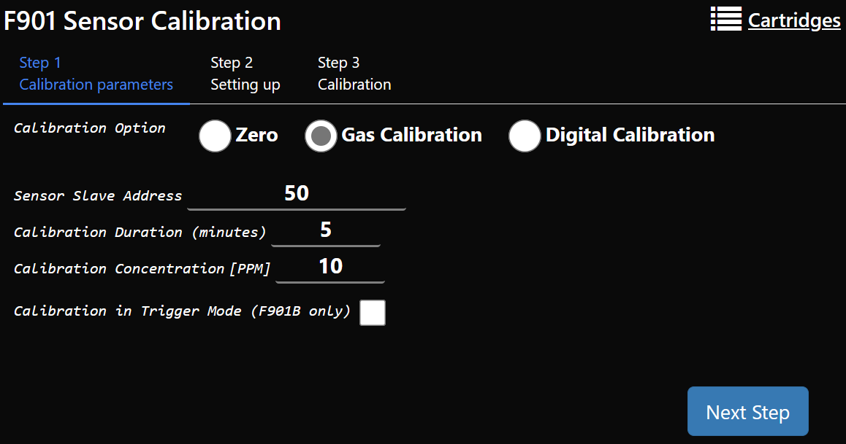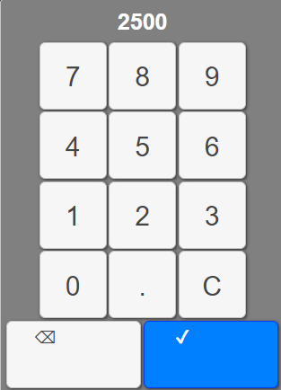

### 4.2. Zero Calibration

Zero calibration should be performed periodically to compensate for natural temperature drift in the gas sensor. Zeroing should also be performed upon initial start-up and prior to every calibration. In applications where temperature swings are significant, daily zeroing may be indicated.

In most cases clean ambient air can be used for zeroing if it is known to be free of any target or interference gases.

#### *4.2.1. Zero Calibration Procedure*

1. Open the CALIBRATION screen on the Controller Module by selecting the **Calibration Menu** indicated by the gage icon in the main bar.



1. Select the **ZERO** radio button as shown by the arrow below.

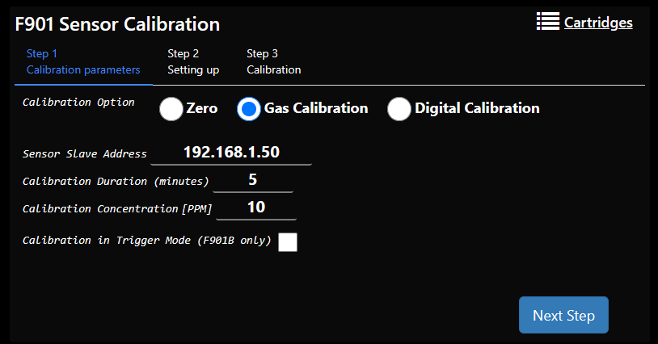

1. Enter the correct ***Sensor Slave Address*** by selecting the entry field (circled in the image above) and entering the address number on the pop-up entry screen.

* For TCP/IP applications, the slave address will be 192.168.1.XX (substitute the Sensor module’s modbus address for “XX”).
* For RTU applications, the slave address will only be the 2 digit modbus address. Be sure to check that the address is correct before continuing.

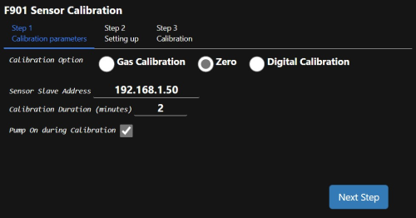

1. Enter the ***Calibration Duration*** time in minutes by selecting the entry field circled below and entering the number on the pop-up entry screen.
2. Tick or untick the ***Pump On During Calibration*** checkbox *(See Figure)* for your application. PUMP ON will be the correct selection in most applications. Consult with the *INTERSCAN Service Dept*. for guidance if unsure.
3. Connect the zero air sample source to the inlet of the sensor module and select the “**NEXT STEP**” button to advance.
4. Graphical user interface, text, application

   Description automatically generatedWait while the Zero calibration timer elapses as indicated by the green timeline bar. Press “**ABORT**” to cancel the calibration if desired.
5. A screenshot of a computer

   Description automatically generated with medium confidenceWhen the calibration timer has elapsed, a “Calibration Completed” window will be displayed as shown below. Press “**OK**” to accept then press “**EXIT**” to return to the main SENSOR CALIBRATION screen.
6. If finished with calibration, select the desired screen from the main toolbar.

### 4.3. Calibration PROCEDURES

The sensor modules can be calibrated in two different ways:

**Gas Calibration** - A known concentration of gas is introduced, and the sensor is allowed to respond over the calibration sampling period. The calibration scaling is automatically updated at the end of this sampling period.

The sources of gas standards include commercially available gas mixtures **diluted with air** in cylinders or permeation devices. **NOTE:** **Gas blends in a balance of nitrogen should not be used with the AccuSafe sensors.**

Delivery of cal gas is most effectively accomplished using a suitable sample bag (5L volume) or properly regulated gas cylinder. Step 8 in the procedure below details safeguards for using pressurized sources for calibration.

**Digital Calibration** – A pre-calibrated sensor is provided by Interscan to replace the old sensor. The new sensor is accompanied by calibration instructions that include a sensitivity value to be entered during the Digital calibration procedure.

#### *4.2.1. Gas Calibration Procedure*

1. Open the CALIBRATION screen on the Controller Module by selecting the CALIBRATION icon on the main toolbar as shown below.



1. Select the **Gas Calibration** radio button as shown by the arrow below.
2. Enter the correct ***Sensor Slave Address*** by selecting the entry field and entering the address number on the pop-up entry screen.

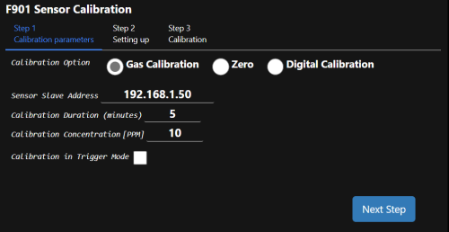

* For TCP/IP applications, the factory set slave address will be 192.168.1.XX (substitute the Sensor module’s modbus address for “XX”).
* A screenshot of a computer

  Description automatically generatedFor RTU applications, the slave address will only be the 2 digit modbus address. Be sure to check that the address is correct before continuing.

1. Enter the ***Calibration Duration*** time in minute.



1. Enter the ***Calibration Concentration [PPM]*** value by selecting the entry field circled above in green and entering the number on the pop-up entry screen. This is the value of the CAL GAS concentration being used for calibration.

**IMPORTANT NOTE: For sensors measuring PPB levels, disregard the PPM designation and enter the caibration gas concentration as a PPB value. EX: enter 5 ppm cal gas as “5000”.**

**IMPORTANT NOTE 2: For sensors measuring PPM levels and displaying one or more decimal places, enter the cal gas concentration value including all the decimal places that would be displayed. EX: for 5 ppm cal gas and a 2 decimal display range enter “500” as the cal gas concentration. For the same concentration and a 3 decimal display range enter “5000”.**

1. The ***Calibration in Trigger Mode*** box should be ticked if Trigger Mode is the active monitoring mode. Leave this box unticked of sampling in continuous mode

**NOTE: CALIBRATING WITH THIS SELECTION MISMATCHING THE SAMPLING MODE WILL RESULT IN CALIBRATION ERRORS.**

**IMPORTANT:** When ticking this box the CAL DURATION setting may update to a default value. **ALWAYS check the CAL DURATION value after ticking the *Calibration in Trigger Mode*** **box and re-enter as needed.**

1. Select the “**Next Step**” button to advance the calibration routine.
2. Connect the Calibration gas supply to the inlet of the sensor module as indicated on the screen shown below. Select the “**NEXT STEP**” button when ready. Selecting the “**RESET**” button will cancel the calibration.

**NOTE:** When using CAL GAS from a pressurized source, be sure to include an “on demand” regulator at the source OR a tee fitting between the source and inlet as shown below. (**limit pressure to 4 PSI or lower**).



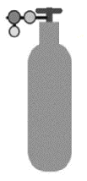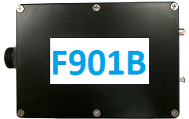

Excess Gas

INLET

T JUNCTION

PRESSURE REGULATOR

1. Wait while the calibration timer elapses as indicated by the green timeline bar. During this time, the gas sensor will respond to the Cal Gas as indicated by the green “***Sensor Measurement***” value. The screen also displays the Calibration Concentration, the previous sensitivity value, and the new updated sensitivity value (shown after cal is completed). Press “**ABORT**” to cancel the calibration if desired.

1. Once the calibration timer elapses a verification process will begin. **This verification can take several minutes especially when calibrating in Trigger Mode.** When verification is complete a new window will display “***Calibration Completed***”. Click **OK** to accept the calibration and **EXIT** to return to the main sensor calibration screen. The calibration scaling will then update automatically and the new sensitivity value written to memory.

#### *4.2.2. Digital Calibration Procedure*

1. Replace the existing sensor with the pre-calibrated sensor provided by Interscan Corp. (See section 5-1, pg. 25 for directions on replacing the sensor). With power applied to the sensor module, allow 24 hours for the new sensor to stabilize before calibrating.
2. Perform a ZERO calibration according to section 4.1.1, pg. 18.
3. Open the CALIBRATION screen on the Controller Module by selecting the CALIBRATION icon on the main toolbar as shown below.



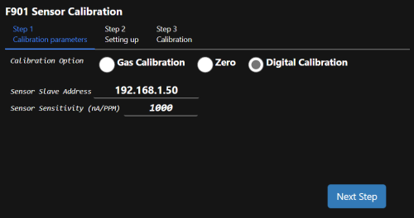

1. Select the **Digital Calibration** radio button as shown below (red arrow)

Enter the correct ***Sensor Slave Address*** by entering the address number on the pop-up entry screen.



* For TCP/IP applications, the slave address will be 192.168.1.XX (substitute the Sensor module’s modbus address for “XX”).
* For RTU applications, the slave address will only be the 2 digit modbus address. Be sure to check that the address is correct before continuing.

1. Enter the ***Sensor Sensitivity (nA/PPM)*** value as indicated on the calibration certificate that accompanied the sensor. Select the field shown above circled in green and enter this value on the pop-up entry screen. Be sure this value is correct before proceeding. Select the **NEXT STEP** button when satisfied with your entry.
2. The confirmation screen shown below will now be displayed indicating that the sensitivity value was set. Select the **OK** button to confirm then select the **EXIT** button to complete the calibration.

## Section 5 – ACCUSAFE SENSOR MODULE MAINTENANCE

### 5.1. Cartridge Replacement

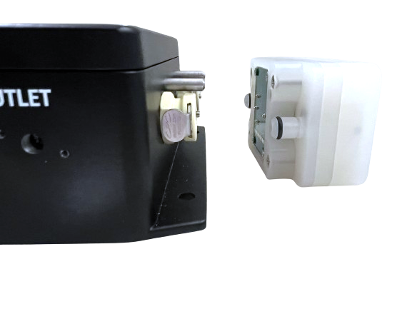

To install the cartridge:

1. Align the inlets of the cartridge with the inlet latches on the sensor module.
2. Apply pressure and push until you hear a clicking sound. This sound indicates that the cartridge is securely installed.

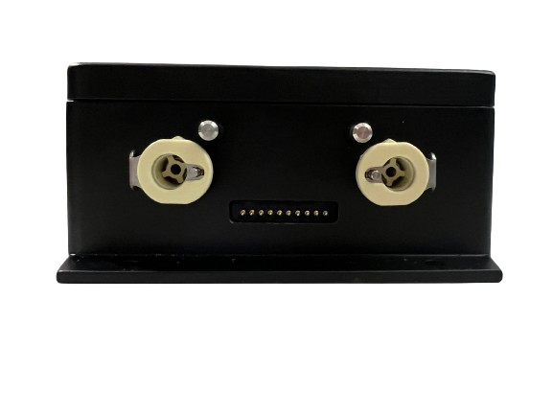

To remove the cartridge:

1. Press inward on the latches until you hear a click while firmly pulling the cartridge away from the device.

### 5.2. RECYCLING SENSOR CARTRIDGES

In the USA & Canada to recycle sensor cartridge, **email Interscan at** [**sales@gasdetection.com**](mailto:sales@gasdetection.com) to request a prepaid return label. Include your name and shipping address. Outside USA and Canada follow local regulations for recycling.

## Section 6 – SENSOR MODULE TESTER APP

The I-901 Sensor Tester app provides the user with computer access to the sensor module’s Modbus registers with both read and write capability. This is most handy for changing the Modbus address of the sensor module if necessary, in a multi-sensor network.

NOTE: This app is for accessing the Senor module(s) only and will not provide access to the AccuSafe Controller module.

The Sensor Tester app is available on our website. Navigate to the F-901 AccuSafe Product Support page, then select the Downloads tab and download **Sensor Tester App vX.X**.

<https://gasdetection.com/support/accusafe/>

Upon click, a security warning window will appear. Click RUN to open the app. The window shown below will open.

The Devices list along the left edge of the window should show all the connected devices in the network. If the device you wish to access is not displayed, do the following to connect to the desired module:

* Make sure the TCP/IP radio button is ticked** as shown above (circled in red).
* Click the “ADD” button. This will open the “Add a device” window as shown below.
* From the dropdown menu at the top, select “F901A”.
* In the “Enter current Device IP Address or RTU Slave address”, enter **192.168.1.XX** (XX = the slave address of the module).
* Click OK.

The Devices list should now show the module added as shown below (module highlighted in blue). The device address should also be listed below the top row of buttons and show “Status Connected”. This process can be repeated for all sensors in the network as desired.

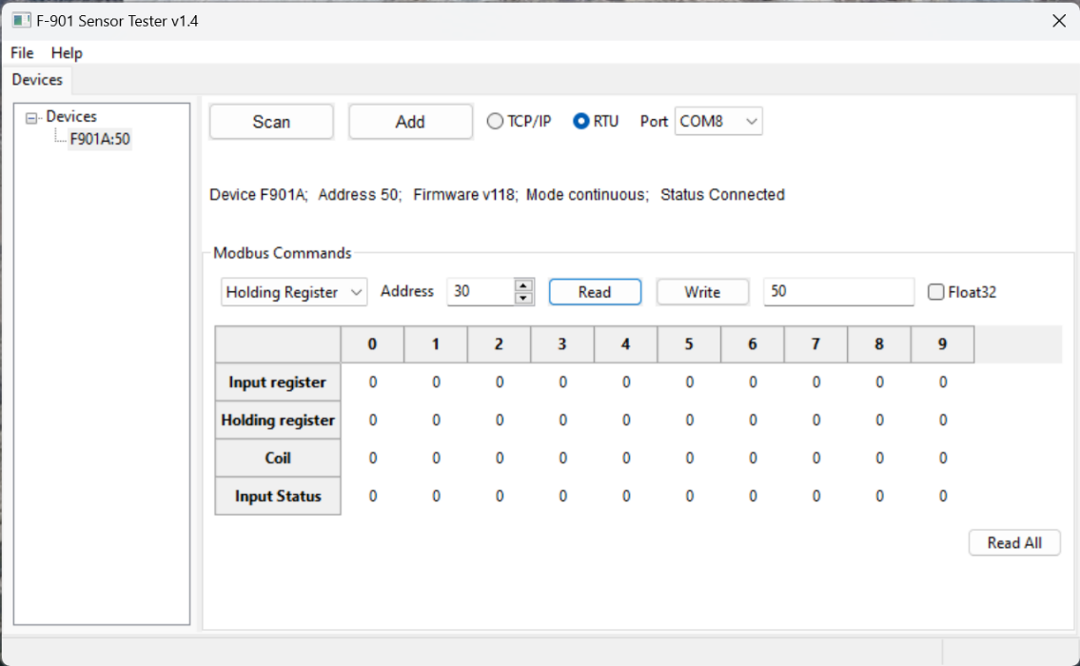

\*\***NOTE:** If operating in RTU mode, tick the RTU radio button before clicking the “Add” button and enter the RTU Slave address (the 2 digit suffix of the TCP/IP address).

Clicking the “Read All” button will then populate the register table with all the current values in the registers as shown below. To access a value in a register not shown on the table:

* Select the register type from the dropdown menu at the left of the circled row.
* Enter the desired address number in the “Address” window.
* Click the “Read” button.

The current value will be displayed in the window on the far right of the circled row. The example below shows the Modbus mode register (31) holding a value of 2.

Writing to an address is the same process but instead, enter the desired register value in the right side window and click the “Write” button to enter that value into the selected register.

## Section 7 - Warranty

***INTERSCAN CORPORATION*** warrants any AccuSafe series instrument and gas sensor to be free from defects in material and workmanship for a period of one year from date of shipment.

***INTERSCAN CORPORATION****’s* sole obligation under this warranty is limited to repairing or replacing, at its option, any item covered under this warranty, when such item is returned intact, prepaid to the Factory (or designated service center).

This warranty does not apply to any of our products which have been repaired or altered by unauthorized persons, or which have been subject to misuse, negligence, or accident, incorrect wiring by others, installation or use not in accordance with instructions furnished by the manufacturer, or which have had the serial numbers altered, effaced, or removed. The sensors are factory-sealed and must not be opened or modified in the field for the warranty to remain in effect. This warranty is in lieu of all other warranties whether expressed or implied.

This warranty does not apply to any of our products, that have had any program and/or software changes incurred, without written authorization from***Interscan Corporation***.

Additionally, warranty on any component shall not exceed the manufacturer's warranty given to ***Interscan* *Corporation***.

## Section 8 - Customer Service

The INTERSCAN Customer Service Department can be reached at the numbers listed below:

Toll-Free: **360-833-8835 x215**

FAX: **360-833-1914**

E-Mail: [service@gasdetection.com](mailto:service@gasdetection.com)

### 8.1 Return Authorization

All units being returned for repair or service require a RETURN AUTHORIZATION NUMBER issued by the INTERSCAN Customer Service Department upon request. This is required to ensure the problem truly needs factory service.

In many cases, problems can be resolved in the field by the user. As such, before contacting Interscan with service questions, consult the TROUBLESHOOTING section of this manual (section 7, page 23) as this may help you to resolve any problems without returning the unit.

Should consulting the TROUBLESHOOTING section of the manual not address your problem, contact the INTERSCAN Customer Service Department as noted below to acquire a RETURN AUTHORIZATION NUMBER. The RMA will expedite prompt return of the repaired unit.

The RMA request form can be found at the following link online…

<http://www.gasdetection.com/contact-interscan/rma-request/>